# System Design Mock Interview: Design Facebook Messenger

**Key Product Goals**

**🎯 Functional Goals:**

1. **Real-Time Messaging** → Users should be able to send and receive messages with minimal delay.
2. **Group Messaging** → Multiple users should be able to communicate within a shared conversation.
3. **Online Presence** → The system should display users’ online/offline status.
4. **Media Sharing** → Support for images, videos, and files in messages.
5. **Read Receipts & Notifications** → Users should know when their messages are seen.
6. **Cross-Device Synchronization** → Messages should be available across multiple devices.
7. **Search & History** → Users should be able to search and retrieve old messages.
8. **Security & Privacy** → Messages must be encrypted and protected from unauthorized access.

**🏗 Technical Goals & Constraints:**

* **Scalability** → The system must handle millions of users with high throughput.
* **Low Latency** → Messages should be delivered with minimal delay.
* **Fault Tolerance** → The system must continue operating even if some servers fail.
* **Data Consistency vs. Availability** → Prioritizing high availability over strict consistency.
* **Efficient Storage & Retrieval** → Storing billions of messages efficiently.

**🔗 Networking Challenges & Solutions**

Since direct **peer-to-peer** messaging is impractical, a **centralized chat server** is required to relay messages. Several approaches are evaluated:

**❌ 1. HTTP Polling (Inefficient)**

* The client continuously asks the server for new messages.
* Wastes bandwidth and causes high latency.

**⚠ 2. Long Polling (Better, but not Ideal)**

* The server holds the request open until a new message arrives.
* Reduces unnecessary requests but still requires re-establishing connections.

**✅ 3. WebSockets (Recommended Solution)**

* Maintains a **persistent** full-duplex connection.
* Allows **instant message delivery** and reduces overhead.

**⚖ Scaling WebSockets**

WebSockets require **persistent connections**, creating **scalability challenges**:

* A single server can only handle **~65,000 TCP connections** due to port limitations.
* **Solution**: Use **multiple API servers** managed by a **load balancer** to distribute WebSocket connections.

**🏗 Load Balancer Strategy**

1. **Distributes WebSocket connections** to different API servers.
2. **Prevents overload** on a single server.
3. **Routes users to the nearest or least-busy server.**

**📡 Message Routing & Queueing**

With multiple API servers, a **Pub/Sub Messaging Queue System** ensures efficient message distribution:

**✅ How Pub/Sub Works**

1. **Messages are sent to a central queue** instead of directly to a recipient.
2. **API servers subscribe** to user-specific message updates.
3. **The queue ensures messages are delivered** reliably even if servers fail.
4. **Scales horizontally** to support **millions of concurrent messages**.

**📩 Offline Message Handling**

* If a user is offline, their messages are stored in a **message queue** and delivered when they reconnect.

**🗄 Database & Storage**

**📌 Choosing the Right Database**

A **NoSQL database** is preferred for scalability:

* **Cassandra / HBase** → Supports **horizontal scaling & automatic sharding**.
* **CAP Theorem Trade-offs** → Prioritizing **Availability & Partition Tolerance (AP)** over strict **Consistency (C)** since minor delays in message ordering are acceptable.

**🏗 Database Schema**

The database consists of the following tables:

1. **Users Table** → Stores user ID, username, and last active timestamp.
2. **Messages Table** → Contains message ID, sender, recipient, timestamp, and message content.
3. **Conversations Table** → Stores group chat information.
4. **User-Conversation Mapping Table** → Tracks which users belong to which conversations.

**💾 Caching & Performance Optimization**

To improve performance and reduce database queries:

1. **Redis / Memcached** → Used as a caching layer to store recently accessed messages.
2. **Read-Through Cache** → Ensures frequently accessed messages are fetched from cache before querying the database.
3. **Content Delivery Network (CDN)** → Used to distribute **images & videos** efficiently.

**📌 CDN Strategy for Media Files**

* Messages with images/videos **store only the file URL** in the database.
* Users retrieve media from **Amazon S3 / Google Cloud Storage** instead of loading it from the backend.
* **CDN caching** accelerates image/video loading and reduces latency.

**📩 Notification System**

Offline users need to be **notified** about new messages:

* A **notification service** triggers alerts when a message is received.
* Integrates with **Push Notification APIs**:
  + **Apple Push Notification Service (APNS) for iOS**
  + **Firebase Cloud Messaging (FCM) for Android**
  + **Email/SMS notifications** for fallback.

**🏗 Final Architecture Overview**

The system integrates **multiple components**:

1. **Load Balancer** → Distributes WebSocket connections.
2. **API Servers** → Handle user authentication and WebSocket connections.
3. **Message Queue (Pub/Sub)** → Routes messages efficiently.
4. **NoSQL Database** → Stores messages and user metadata.
5. **Caching Layer** → Reduces database calls.
6. **Object Storage + CDN** → Optimizes media file access.
7. **Notification Service** → Alerts offline users about new messages.

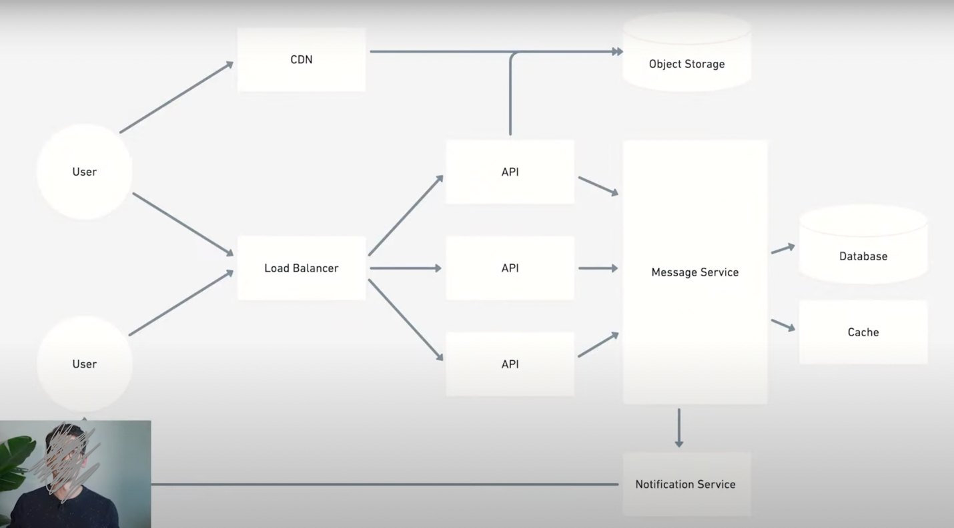

**🔢 Insights Based on Numbers**

1. **65,000 TCP connections per server** → Requires horizontal scaling.
2. **Millions of messages per second** → Demands a high-throughput system.
3. **Thousands of API servers** → Needed to balance WebSocket connections and ensure performance.
4. **Latency under 100ms** → Crucial for a seamless user experience.

YT Video: <https://www.youtube.com/watch?v=uzeJb7ZjoQ4>

My chatgpt: <https://chatgpt.com/g/g-GvcYCKPIH-video-summarizer/c/67bd3552-0804-800f-b76d-b83c80094f48>